Method: Slope and Bearing

For waded streams only (slope and sinuosity will be determined using GIS for rafted rivers):

Slope

One person standing at the water’s edge of a transect at a higher elevation, will site downstream toward a stadia rod at a lower transect. LevelHeightOnRod (cm) minus
EyeHeightonLevel (cm) provides the elevation distance (cm) between transects.
Segments evaluated are normally between primary and secondary transects (e.g A0-A5), but intermediate measurements may be used (e.g. where vision is blocked or if the level sights over the top of the rod).
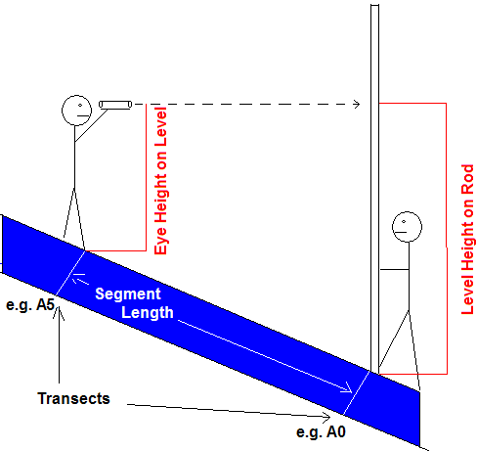

Bearing

One person standing at a transect at a higher elevation, will site downstream (parallel to the thalweg direction) toward a lower transect. Segments evaluated are normally between primary and secondary transects (e.g A0-A5), but additional measurements may be used to avoid having the site line cross land at a bend in the river. Bearing (degrees) is always reported in the field from top to bottom transect and are always reported in the field as uncorrected (no adjustment for magnetic declination).

